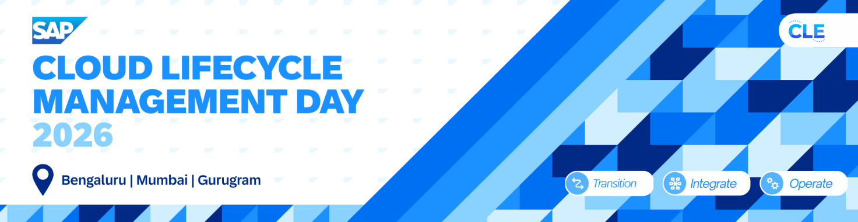
PUBLIC

Understanding Readiness check
Version: 1.0
Date: 2026-08-28
Owner: Ananth Pai

Objective: The objective of this exercise is to familiarize you with SAP readiness check feature and how this can be achieved.
Pre-requisites: implementation of all the SAP notes related to readiness check, and SI check items.

Running readiness check.
1 | Running readiness check | In SE38, run the report RC_COLLECT_ANALYSIS_DATA  Select the right target version  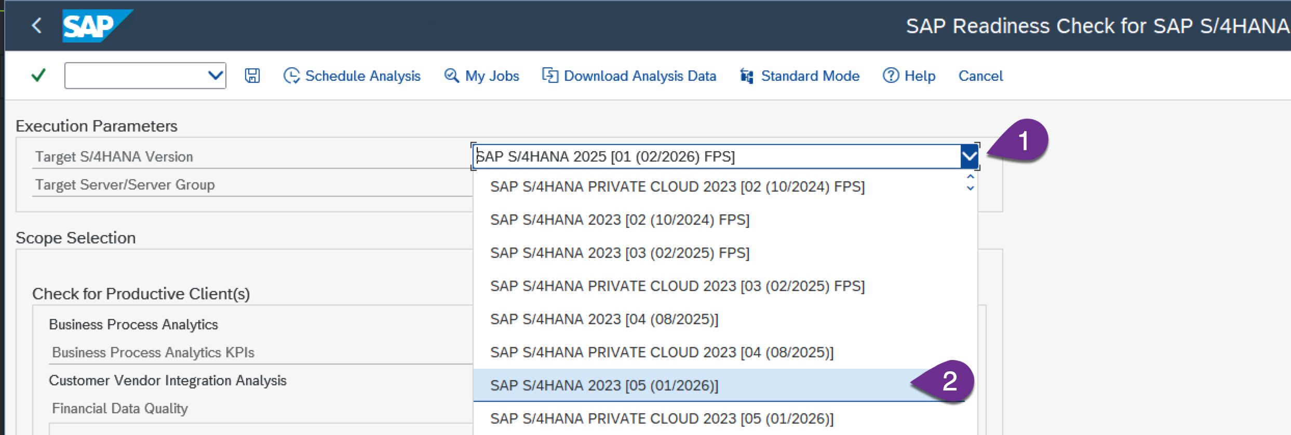  For the exercise we have selected the SAP S/4HANA 2023 SPS05
2 | You can choose all the options or select individually.  For the current exercise de-select the below items  - Customer vendor integration analysis  - Financial data quality  - Data volume management  Select the schedule analysis. | 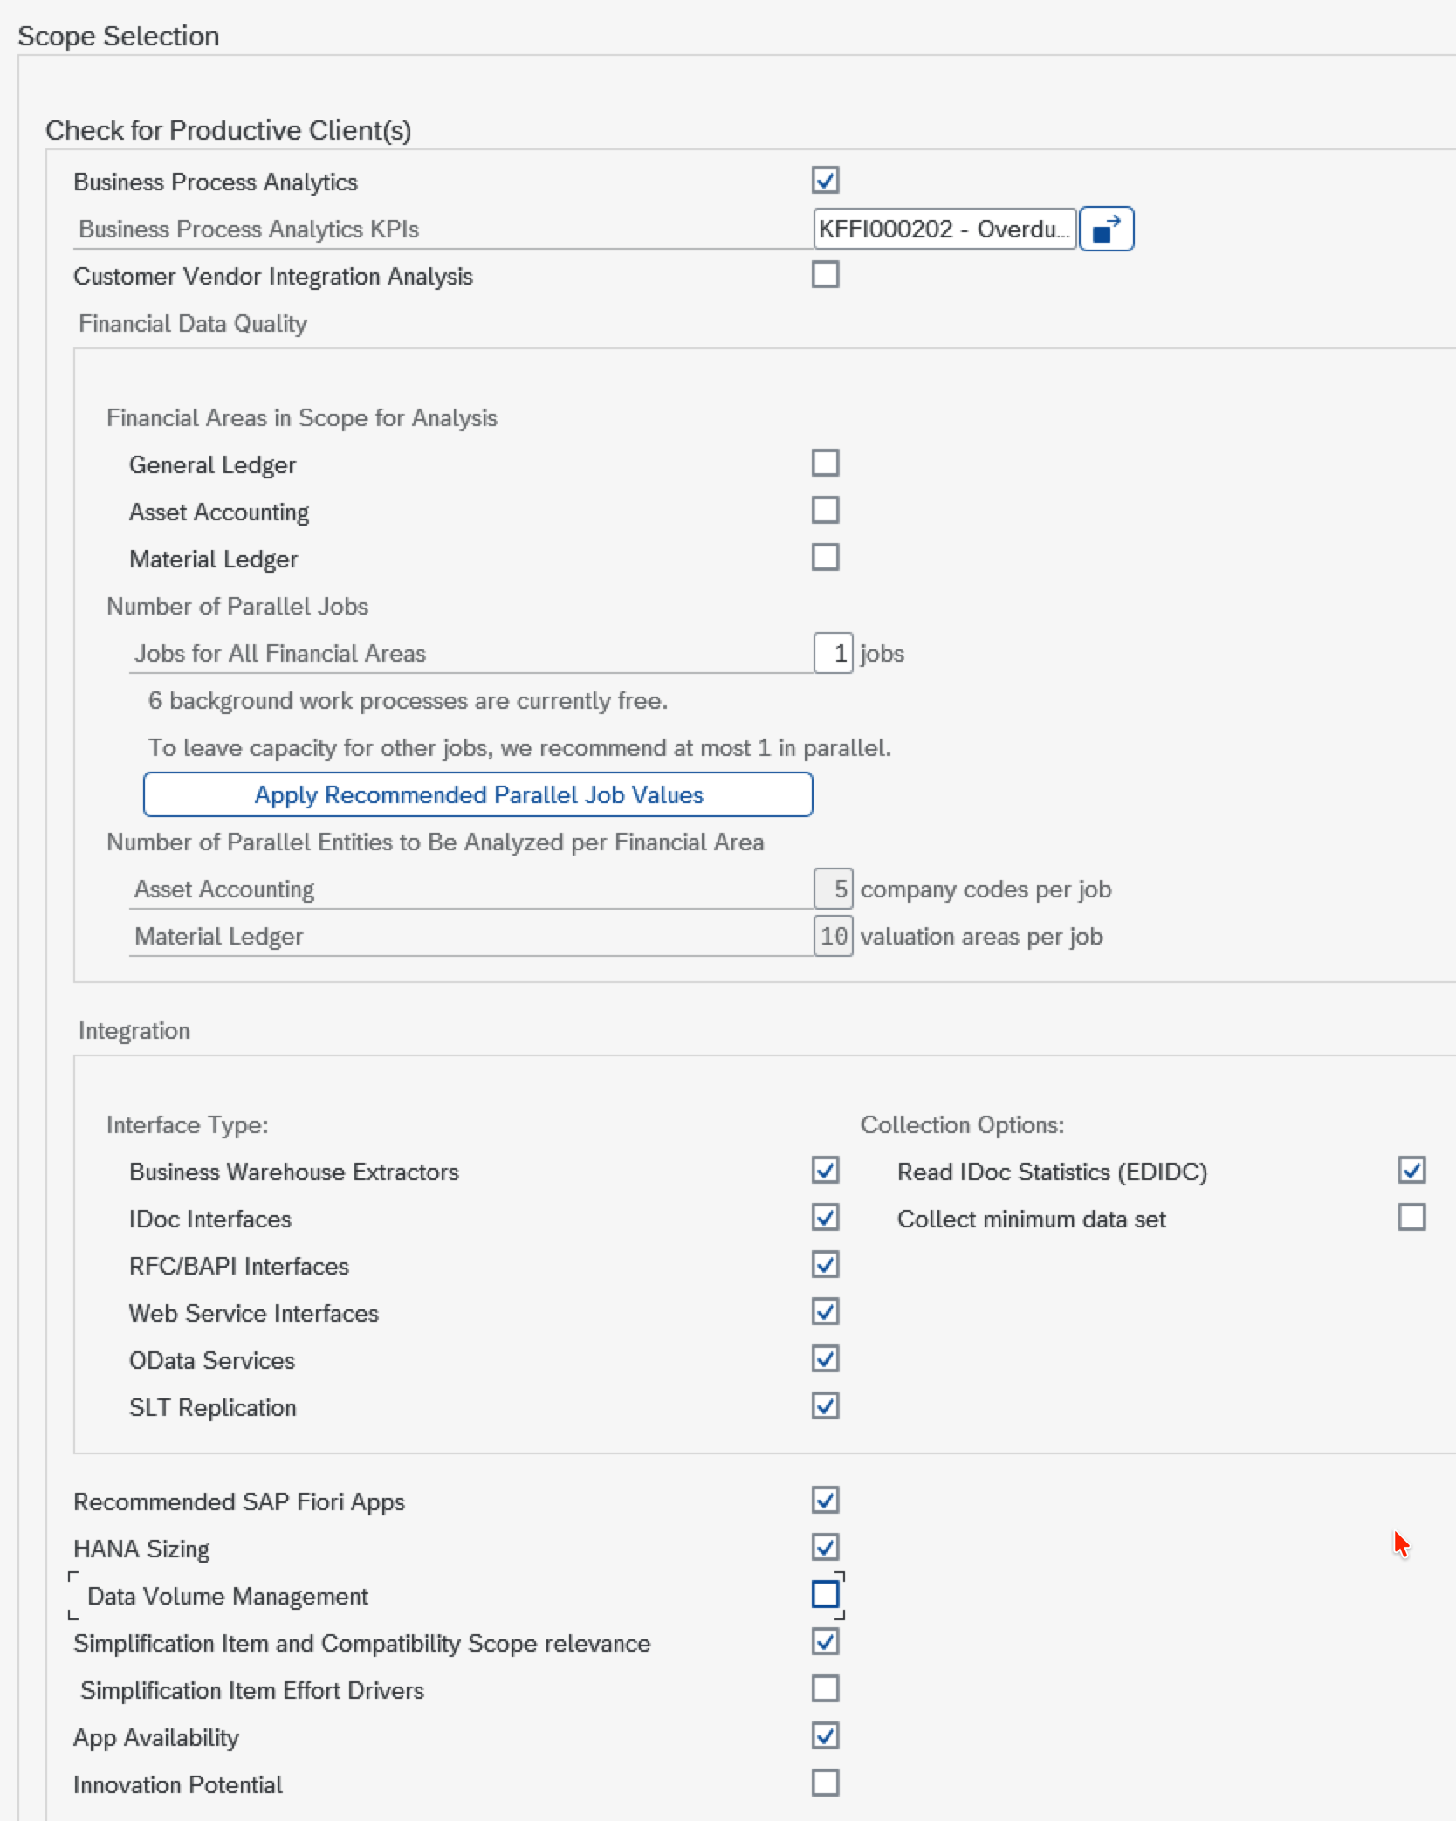  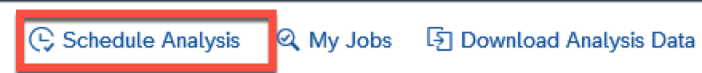
3 | Download the analysis data. | Once the job has been completed, open the report RC_COLLECT_ANALYSIS_DATA report and select the download analysis data option. This should give you the latest completed run data in ZIP format.  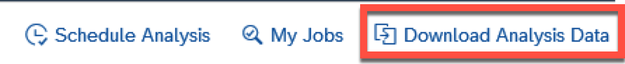  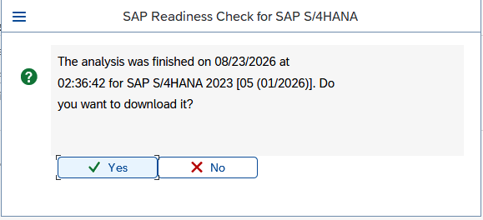
4 | Generate the readiness check report | Open the url https://me.sap.com/readinesscheck  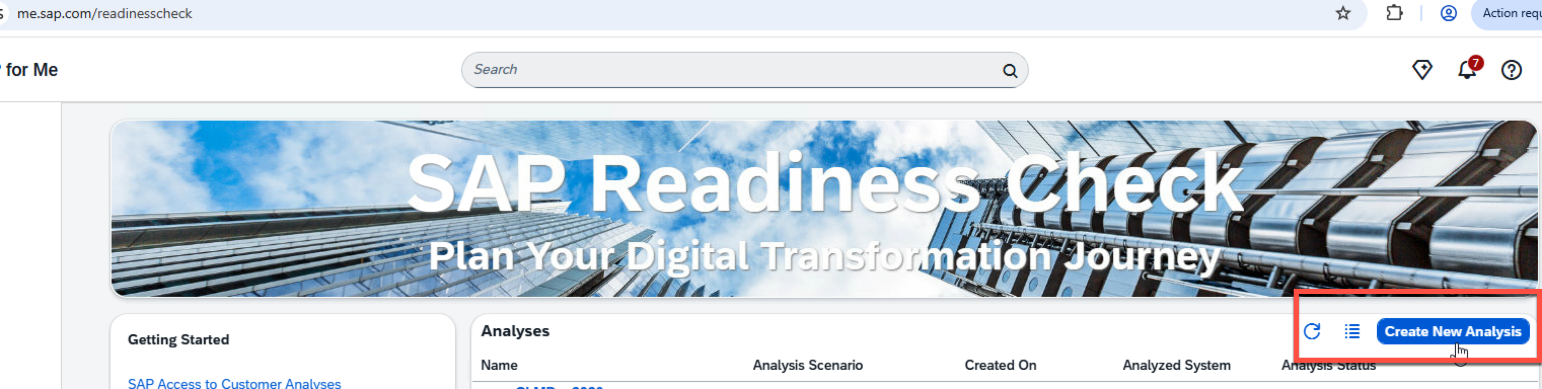  Upload the download readiness check zip file from step 3 to this as shown below.  For this exercise you can use the RC2AnalysisDataABA20260823.zip file available in the folder.  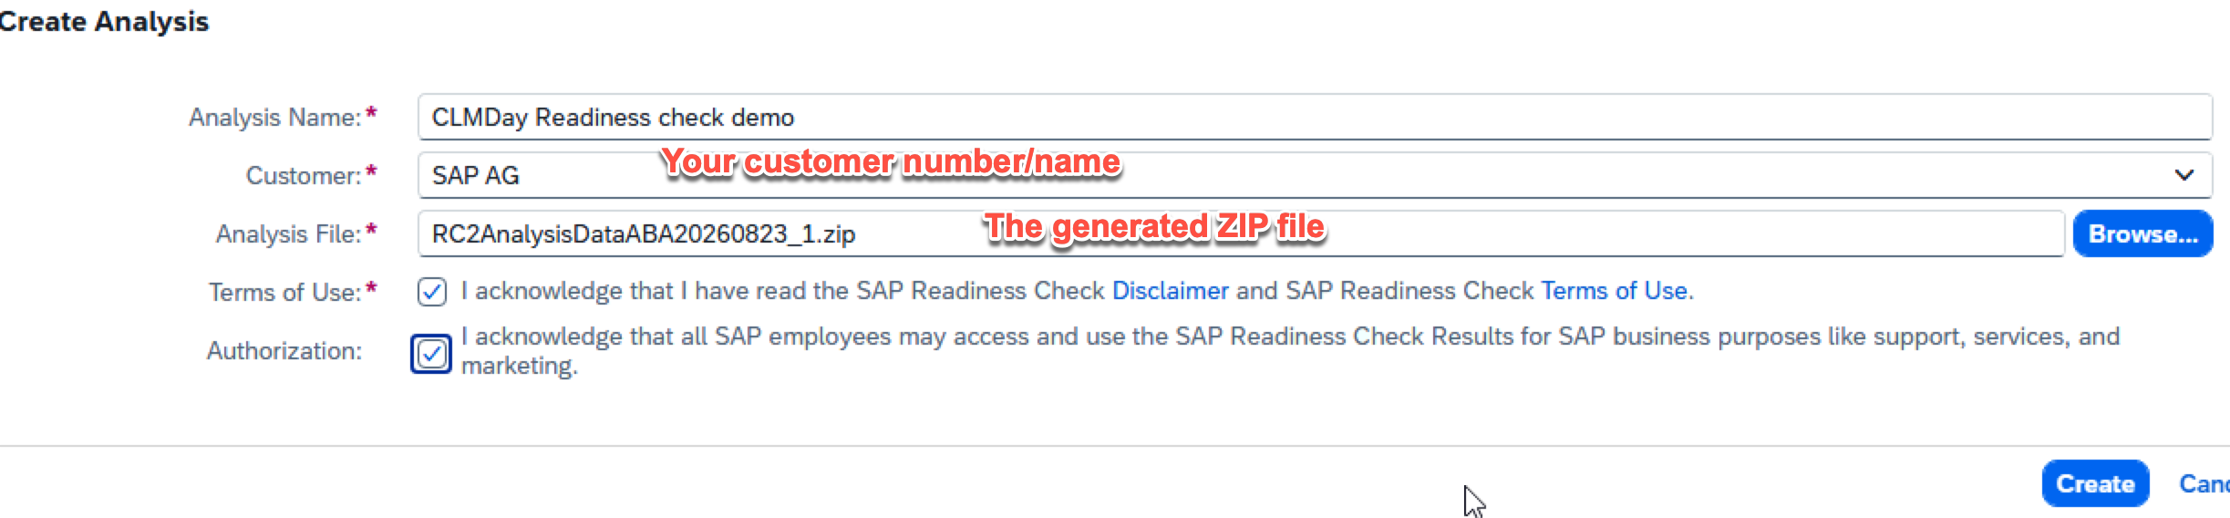  The report generation will take some time. Once its done, you can download the data.  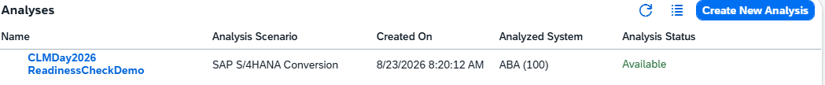
5 | Access and understand the impact from the readiness check | You can open the report for details analysis or download the report which will in a zip format. This consists of various details about the impact of SAP S/4HANA conversion on the system.  If you cannot open the report, the output of this exercise is available for your understanding.  Readiness check output.pdf  And SAP S4HANA Conversion.zip
6 | Running the Simplification Items check | Between SAP ECC and SAP S/4HANA there are lot of changes in the data model and functions. The simplification items check will help you identify the changes from a business process perspective, structure perspective and the system readiness for a technical SAP S/4HANA conversion.  You will have to run the report /SDF/RC_START_CHECK with the right target version intended for the SAP S/4HANA conversion. In our exercise we are going to use SAP S/4HANA 2023 SPS 05 as the target version.  In SE38 run the report /SDF/RC_START_CHECK with the below options  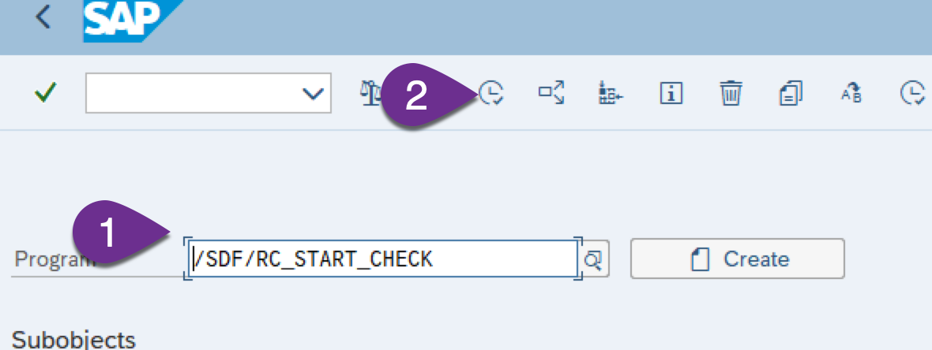  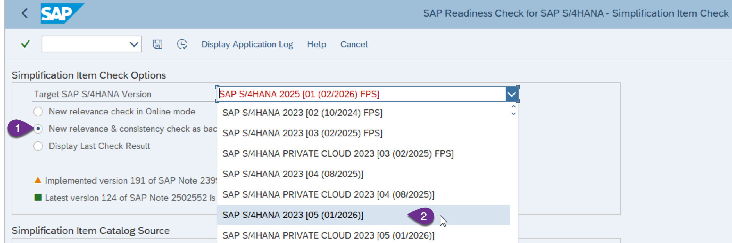  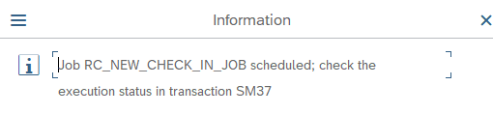  Once the job has been completed you can review the results in the below step
7 | Review of the results of Simplification Items check | For reviewing the results, you will have to run the same report in SE38 with selection Display last check result . Please note that you will have to use the same target to see the results, if you use a different target you will not see any results.  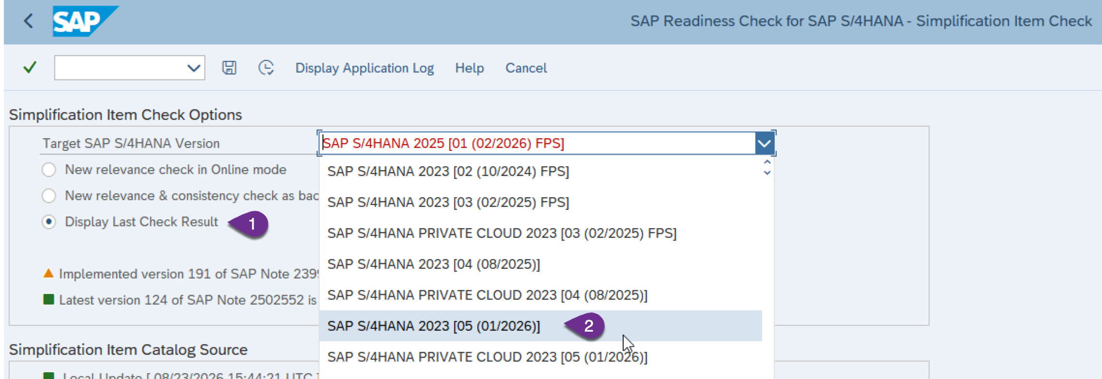  The results would be something like this  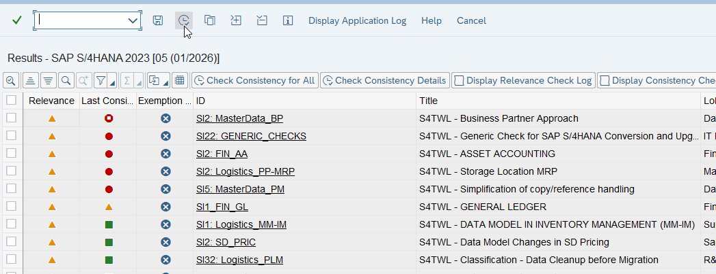  There are different levels of errors,  e.g. the first one SI2: MasterData BP is at level Abortion, while the next one SI22: GENERIC_CHECKS are at level error 12.  All the errors in the SI check items must be fixed before you start the SUM tool  For every SI check item, there is a SAP note associated, you can find the SAP note also in the output.

After completing this exercise you will be able to understand the readiness of your SAP system which you are planning to convert to SAP S/4HANA. www.sap.com.

